Test layout of Learner Performance & Intervention Tracker

Page layout test 1
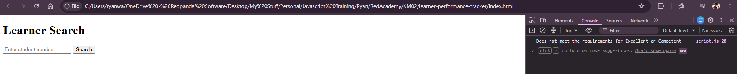

Page layout test 2.
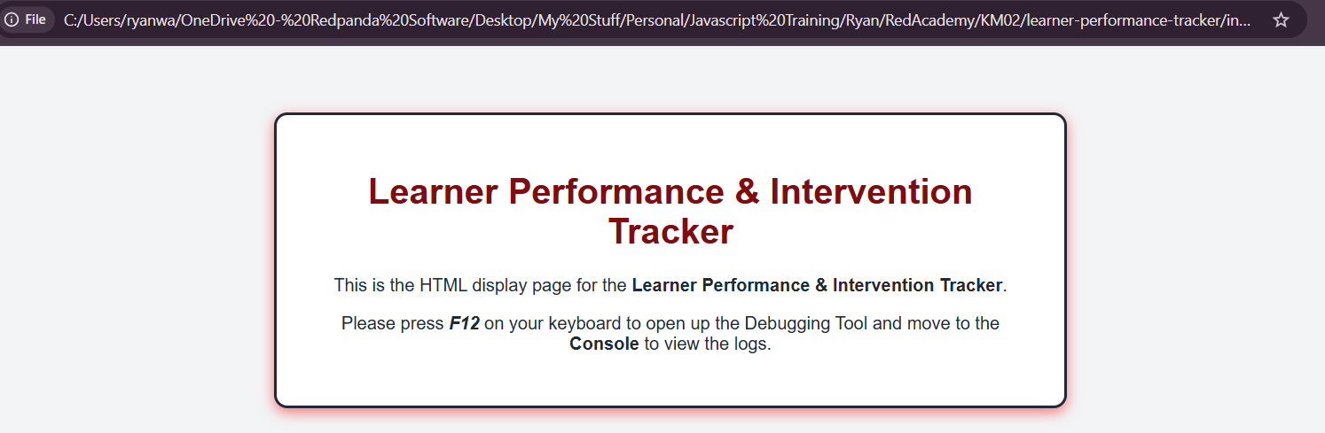
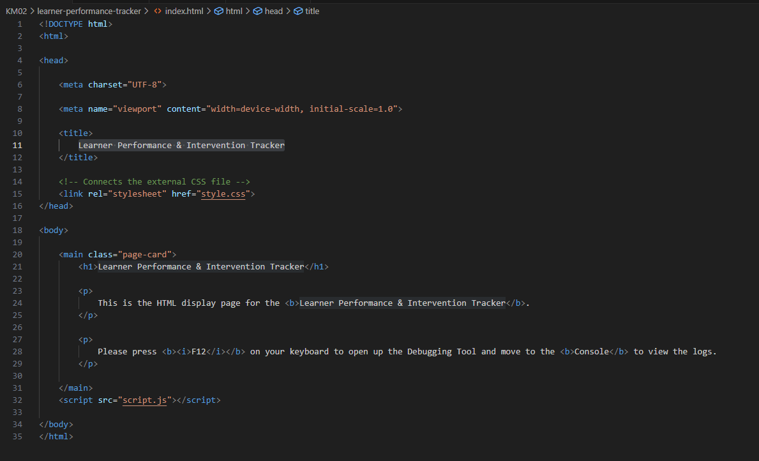
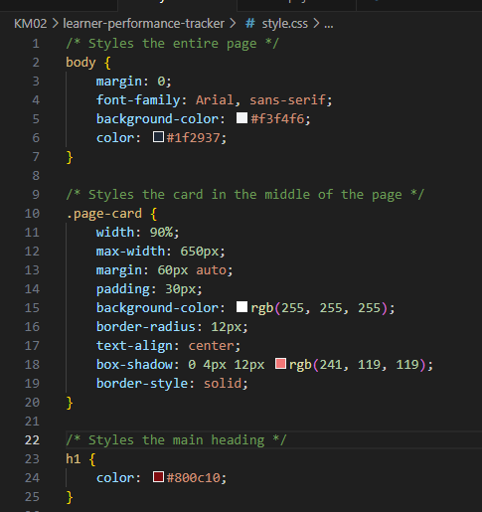

JavaScript Function test 1
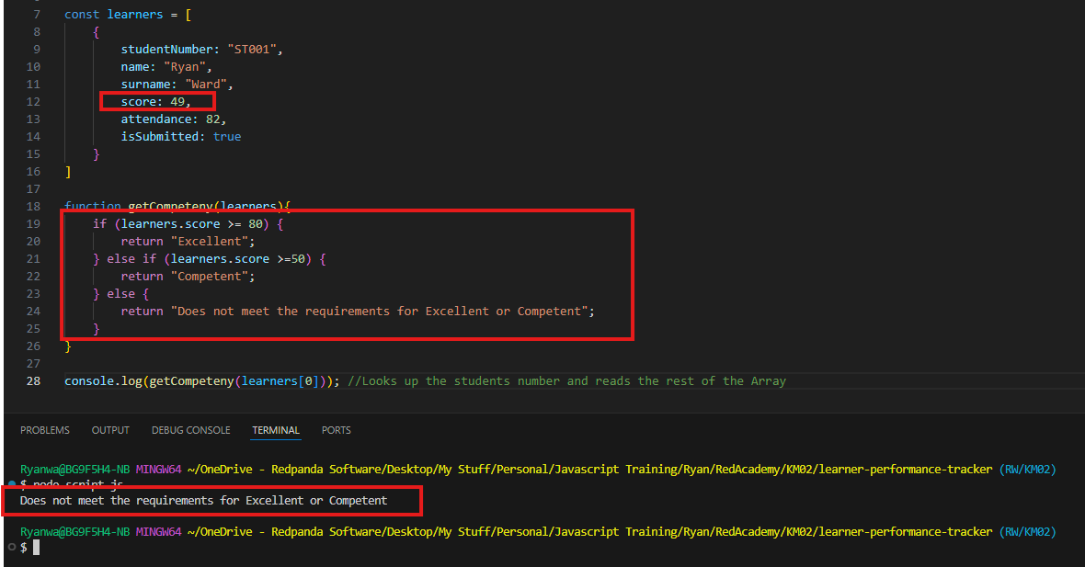
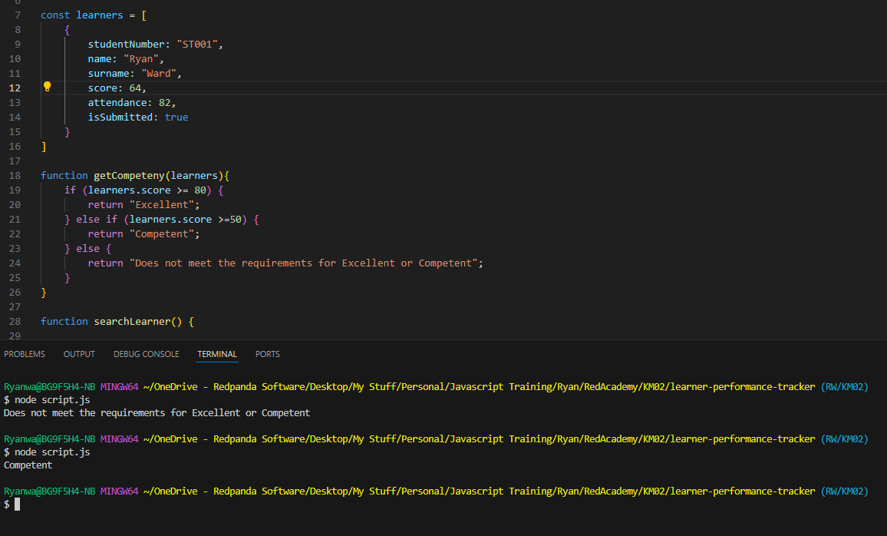
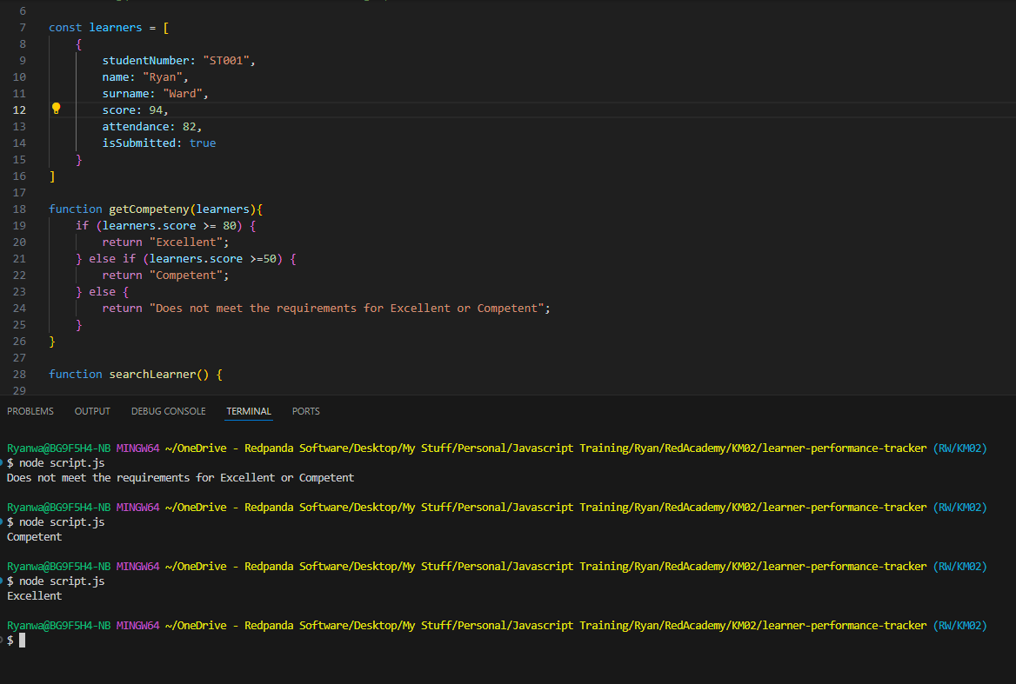

JavaScript Object list of learners:
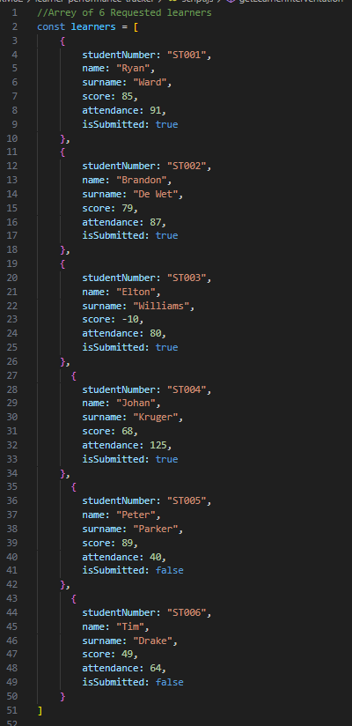

Function to mark sure numbers are solid and cannot be less than 0 nor more than 100.
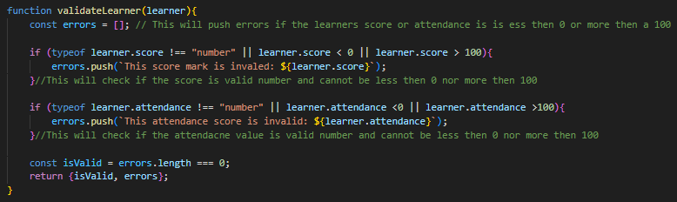

Function to mark the learners as Excellent, Competent or does not meet the requirements.
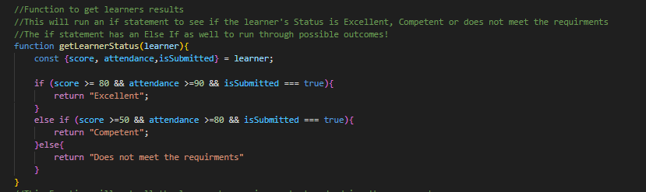

Function to get the learners who need to have an Intervention with a reason way.
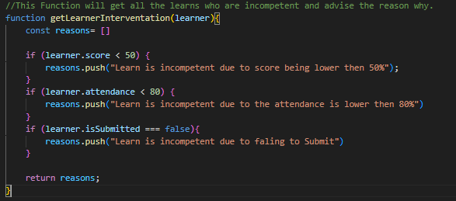

Function to all learners details and do a class average score.
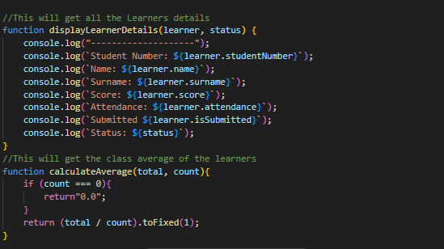

Function with a loop and array to which it will count all the students who are Excellent, Competent or Not yet competent
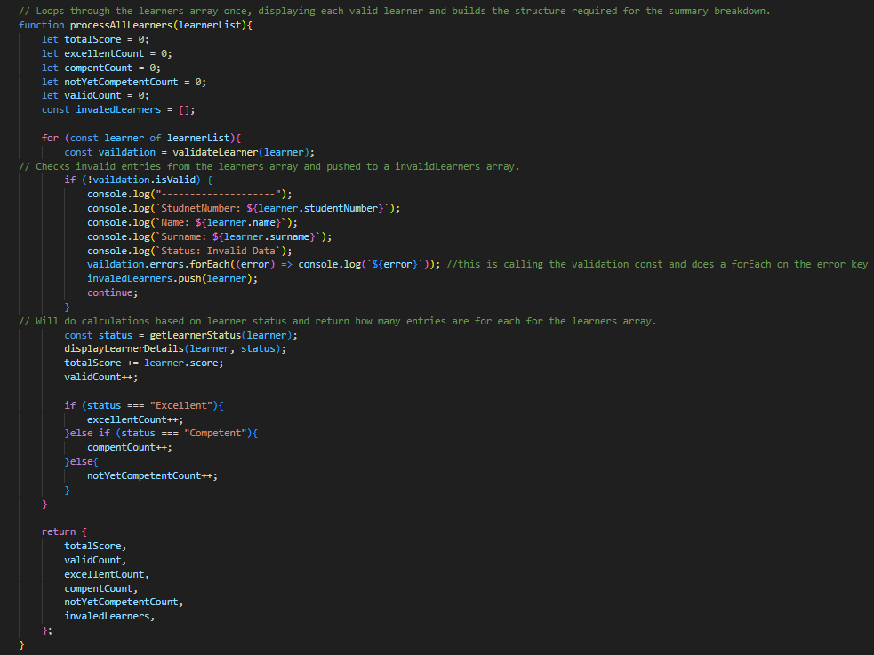

Function that will display on the information of learners, performance summary and intervention.
